Search”perioperativeCPD.com” on Google or any search engine
Or Click this link:
https://www.perioperativecpd.com

Follow the navigation pane at the top of the home page for the relevant courses developed for each category


Then you will see relevant courses. Chose the topic you are interested in then click “download” PDF, as shown in the following screenshot. Now the course is downloaded in PDF format and is ready to read.
PS: You don’t have to save the PDF onto the computer unless you want to.

After you have finished your reading, you can take the relevant quiz. To do this, you need to go back to the previous page and click “take the test” button that is next to “download PDF”.
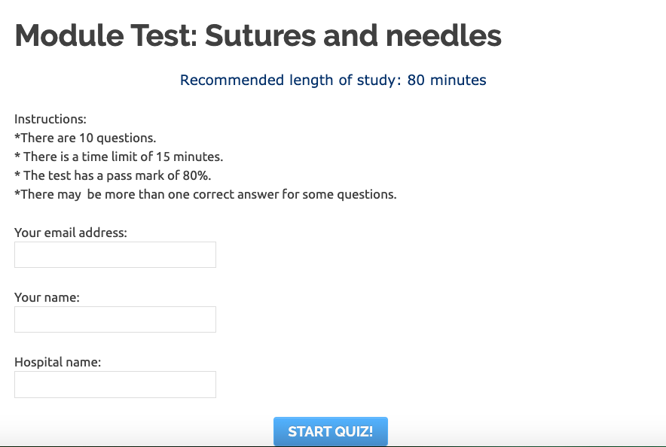
Read the instructions first (very important!). Fill in the boxes and now, you are ready to take the quiz, click “Start Quiz”
PS: Your test is timed, remember to check your residual time while you are doing your test.

You will get a certificate link once you pass with a score of 80% or more, click “print your certificate” from the page to print out your certificate.
PS: The email functionality doesn’t always work so please print your certificate now (can be printed as a PDF format) if you want to save it onto your computer.
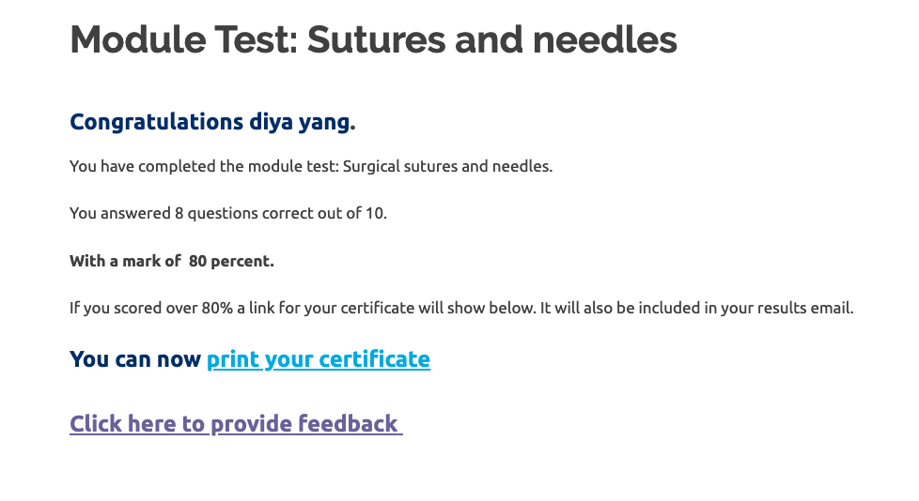
Now you are ready for next course

