MOODLE GUIDELINES
How to make the website (Moodle) work!
It is important to read this document before using the system for the first time.
Always view your course resources before commencing the test.
These guidelines will help you use Moodle at any time.
There is no need to use the hard copy manuals as these are saved electronically under ‘resources’ in Moodle.
As this is an online course you are advised to use the online resources provided.
Logging into Moodle will be shown in the guidelines for both Apple (Mac) and Windows computers. The rest of the instructions are the same no matter what type of device you are using.
Guideline Index
Accessing Moodle using Windows pg.3
Accessing Moodle using Mac pg.7
You are now logged in pg.10
How do I access the resources? pg.13
Accessing a PDF File Resource pg.13
Accessing a Word File Resource pg.18
I am ready to take the test pg.21
How do I refresh the page for taking the test? pg.22
Where do I enter my answers? pg.24
How do I use computer symbols for calculations? pg.25
How do I use a resource during the test? pg.26
I want to open a resource on the same screen pg.26
I want to have separate Tabs for resources pg.32
My profile settings and progress pg.33
Feedback – we want to hear from you pg.35
How to put my study days and conferences reports/reflections on Moodle?
pg.36

Accessing Moodle using Windows

1. Log on to the computer as normal either at home or at work.
2. Open the internet. If you are in Boulcott Hospital, click the Moodle symbol in the computer 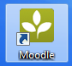 if you cannot find it click to open the internet.
3. If you did not use the Moodle symbol; in the “Address bar” at the top of the page

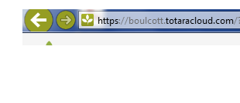
Type https://boulcott.totaracloud.com
4. Locate the log in button as shown below and click.

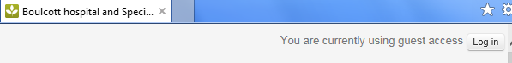
Click the login button

Please note that some computers including smart phones and tablets may not have this log in button.

You will find this unlabelled menu button at the top right hand corner as shown below.

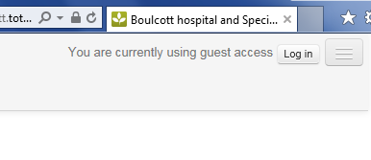
Click this button to log on

Then you will be taken to the following page to click the login button

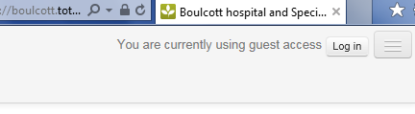
Click here to log in

Enter your username and password that you were given to use as initial log in.
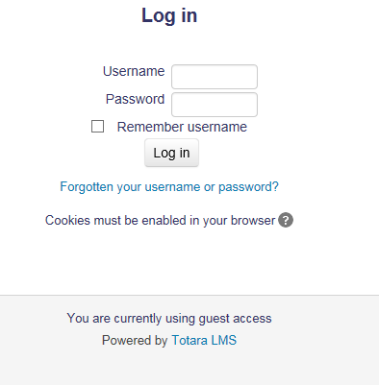

Moodle will ask you to change your password as below
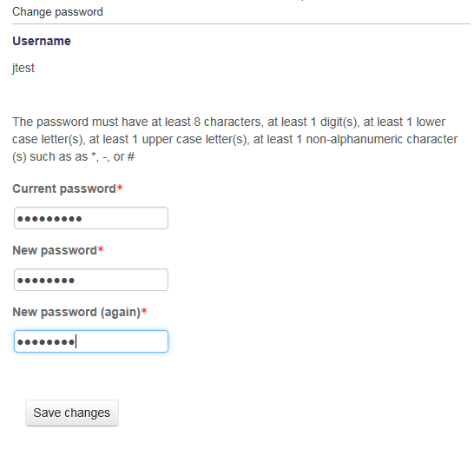

Once you are logged in, you will be directed to the course (s) that you are enrolled in.

Accessing Moodle using Mac (Apple) computers

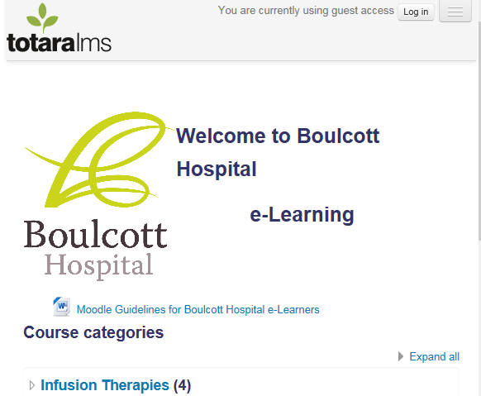
Click the login button

Enter your login details that you were given to access Moodle
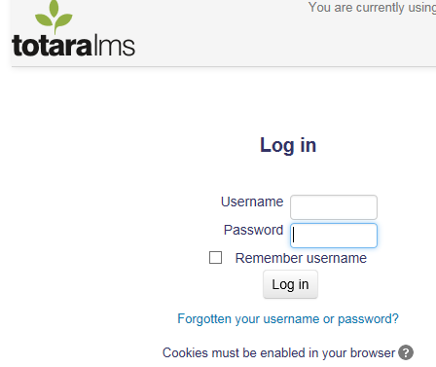

Moodle will ask you to change your password as below

Once you are logged in, you will be directed to the course(s) that you are enrolled in
Welcome to Moodle, you are now logged in

Welcome to Totara LMS Moodle
You are now logged in

- Click “My courses” to see the list of courses you are enrolled in.

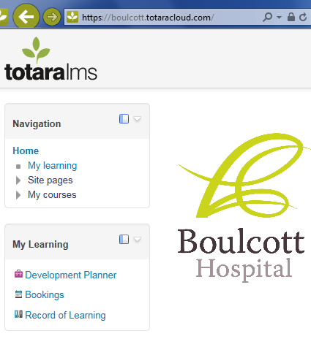
Click ‘My courses’ to see your courses

- Choose a course that you want to do from the list and then click on it.

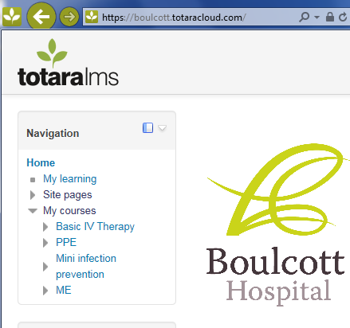
Click the name of the course to start

- Moodle will take you to the resources and assessments page for the course(s) you are enrolled in.
Below is an example of this.

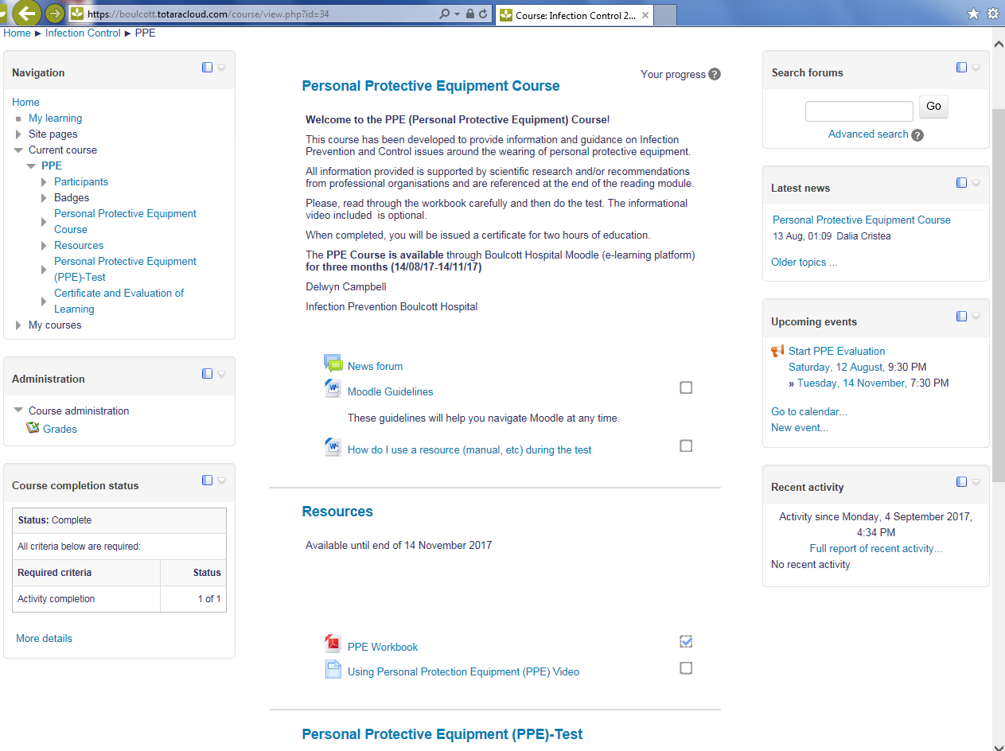

How do I access the resources I need for my course?
The resources are manuals, work books, other documents, and videos appropriate to the course(s) you are enrolled in. In this example, you have to view at least the PPE Workbook in order to proceed to the test. You will see the unchecked boxes next to the resources. You can only access the tests once they are ticked.
Just click on the resource you want to view.
Videos will play automatically in a separate page. Moodle will ask you to open or save manuals, workbooks and other documents. Click open to view the resource.

Accessing a PDF File Resource

 A PDF File Icon

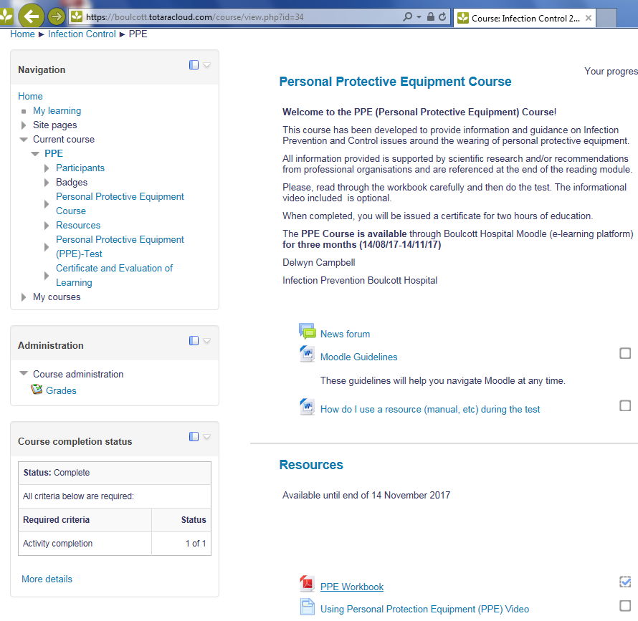
Click the resource or workbook (PDF file) directly to open it
Please go through these resources before taking the test

Click the resource or manual directly to open it.

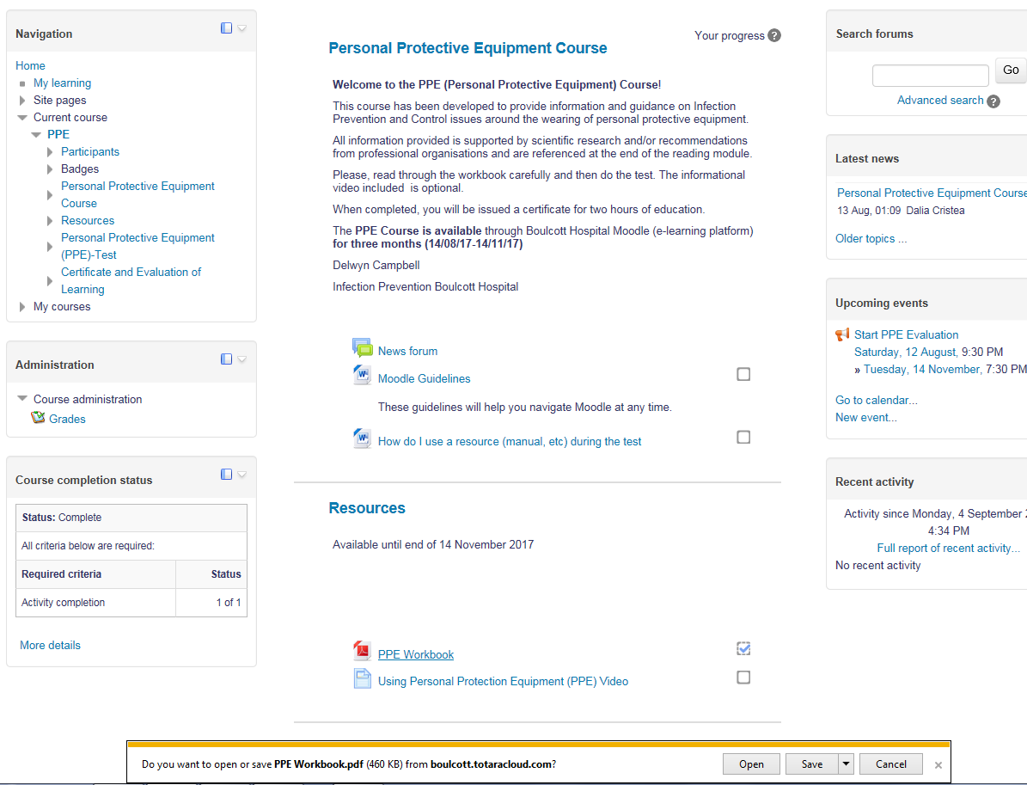
If a window like this comes up, click open to view.
Only click ‘save’ if you want to save in your personal computer and read later.

Once your document is open you will see a toolbar on the left hand side to help you locate pages in your document.

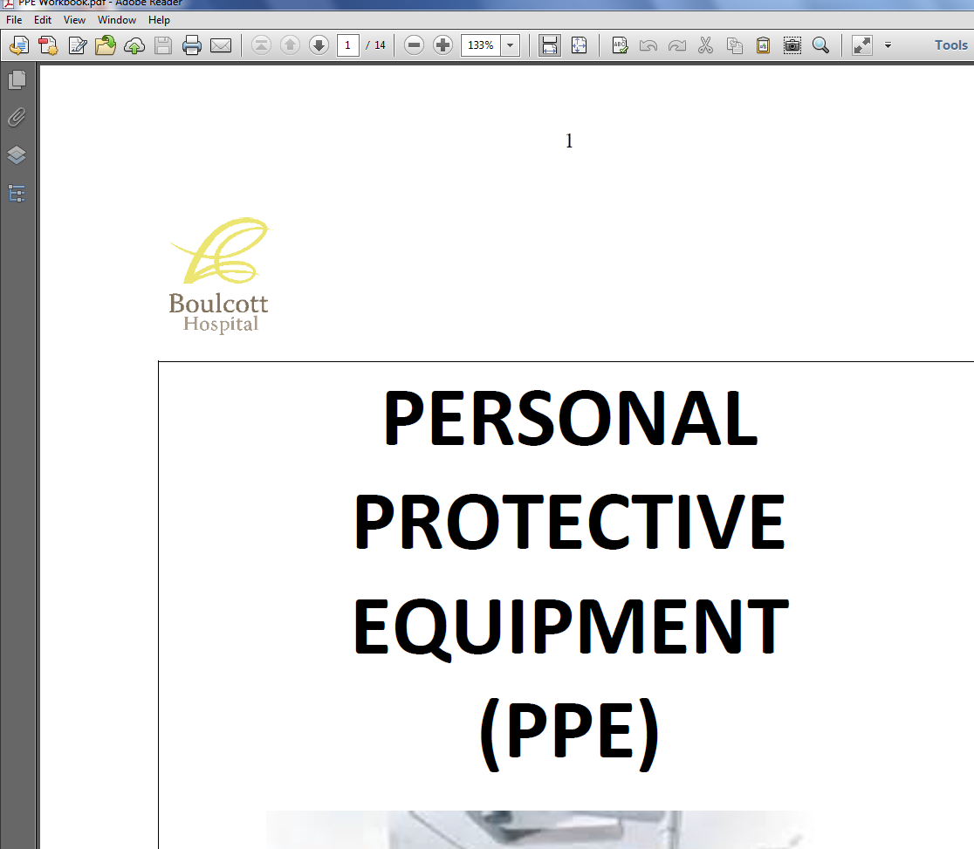
Page Thumbnails
Click on it to go to specific pages

Once the Page Thumbnail is open you can now choose what you want to read by clicking on the topic/page.

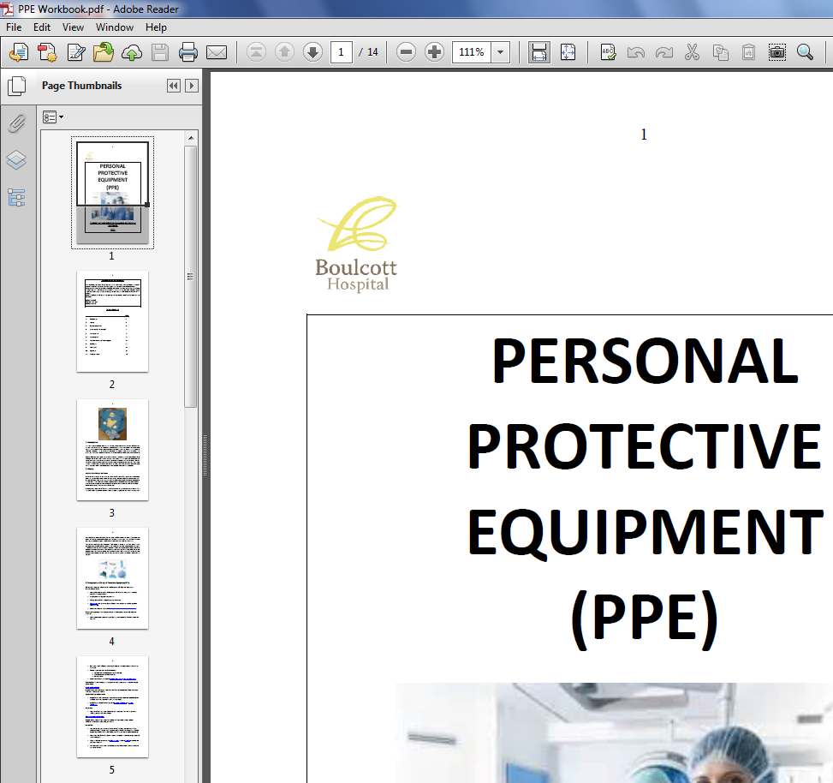
Choose what you want to read by clicking on the page

Accessing a Word File Resource
A Word File Icon

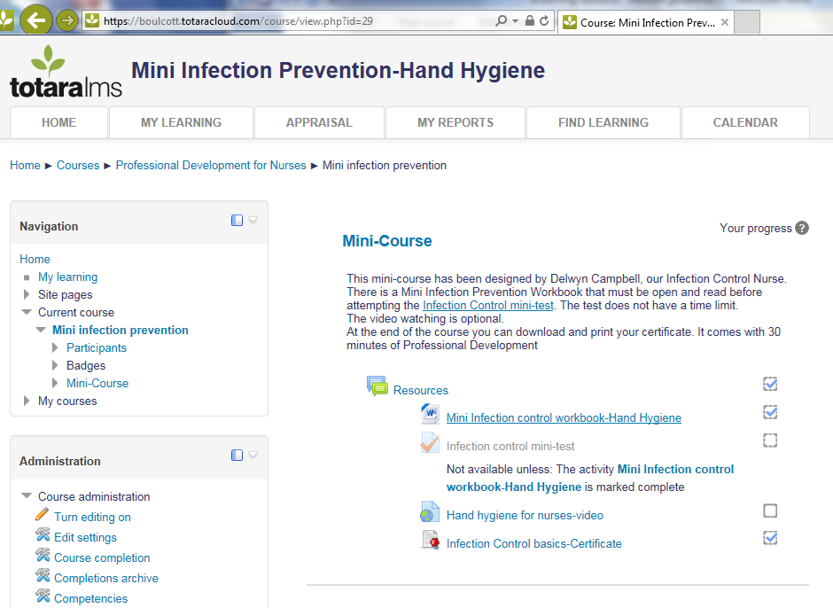
Click the resource (Word file) directly to open it

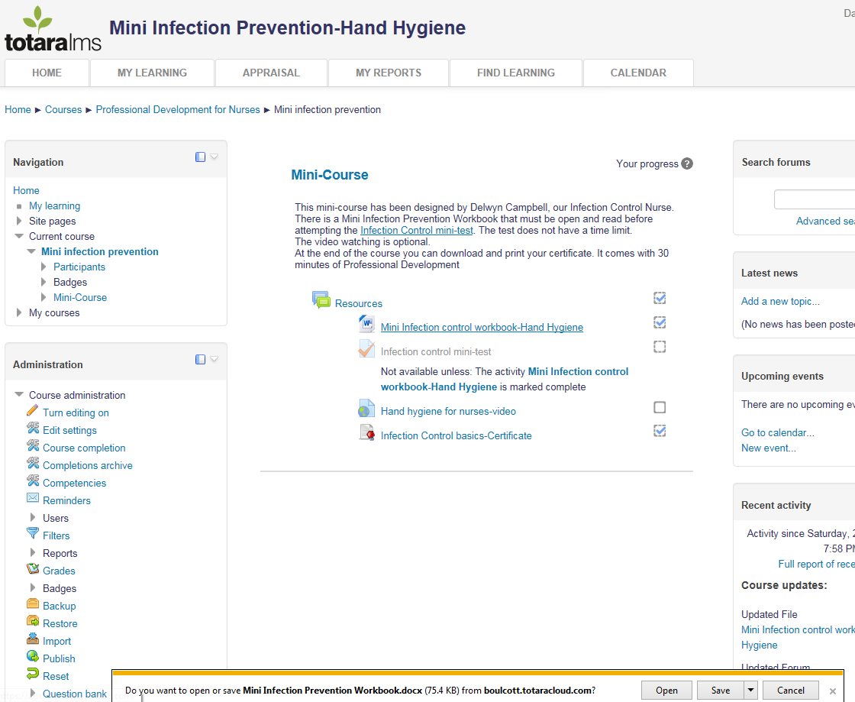
If a window like this comes up, click open to view.
Only click ‘save’ if you want to save in your personal computer and read later.

You can drag the cursor to see all pages

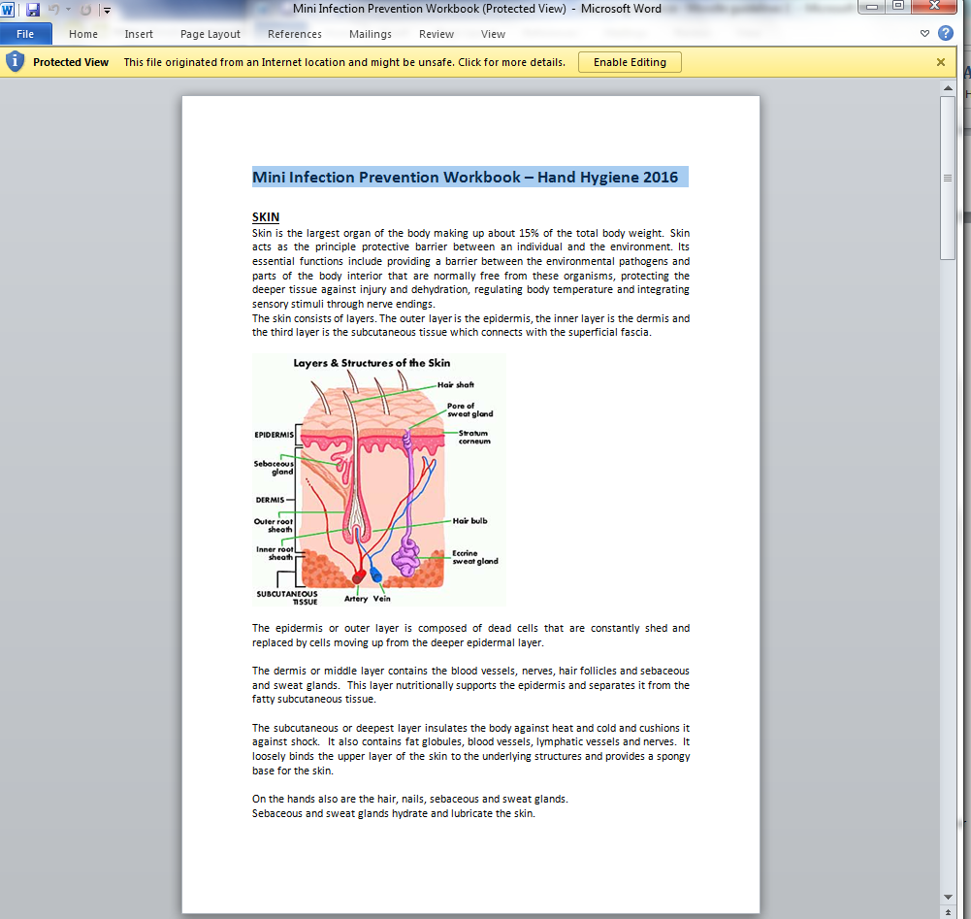

I am ready to take the test

Once you have viewed your resources you can take the test when you are ready. You have to refresh your resources page so that you have the boxes checked like the following
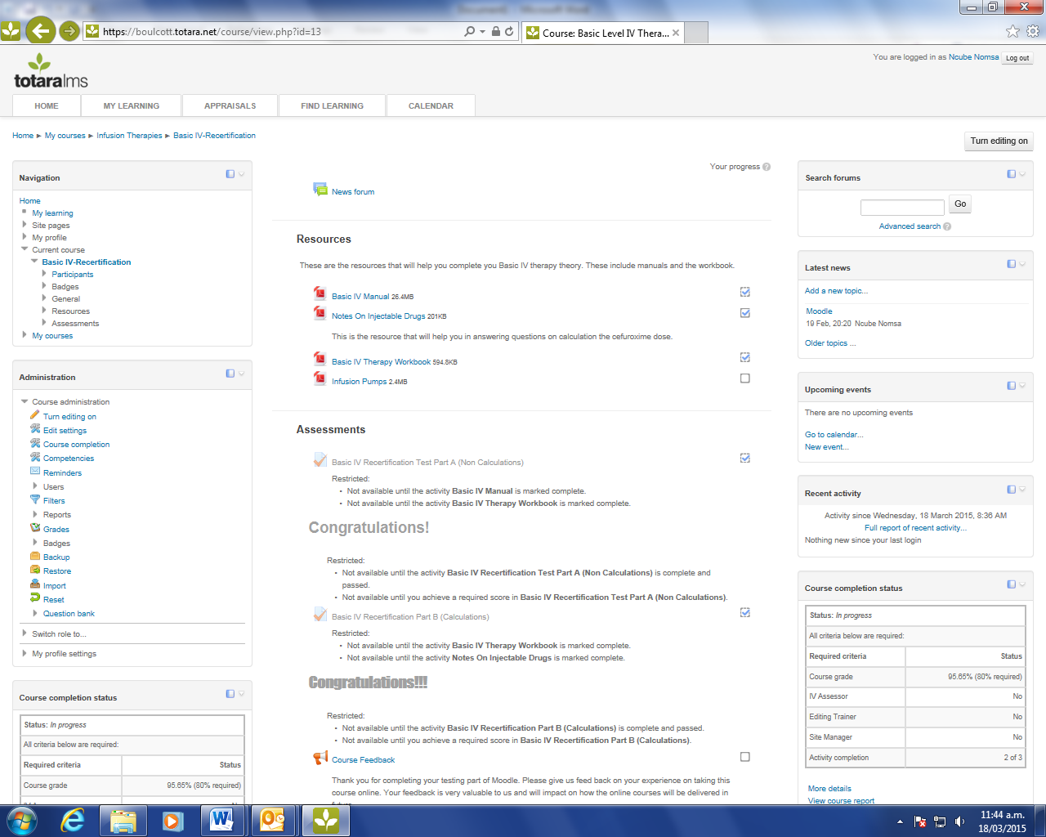
Checked boxes

How do I refresh the page?
To refresh your page just click ‘Ctrl and R’ at the same time on your computer. Remember computers are different but this is an example.
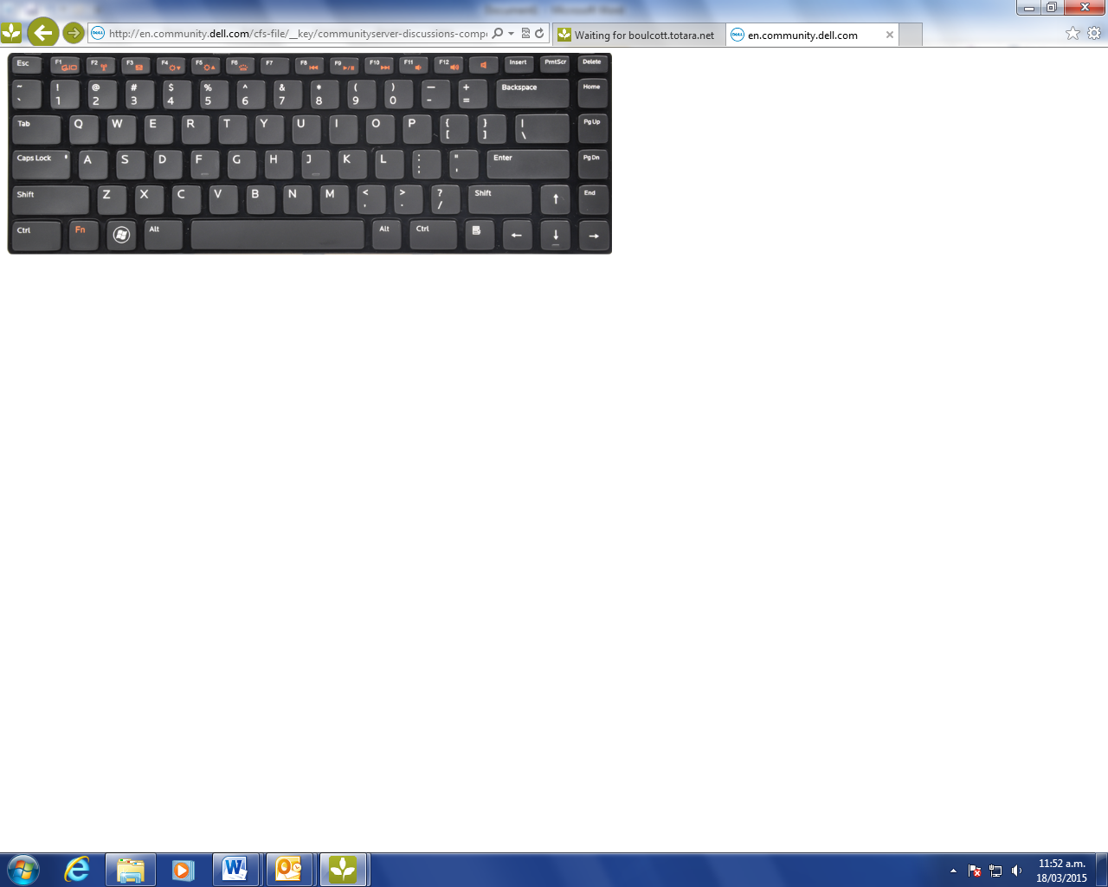
Click these buttons together to refresh the page

Alternatively go back to you home page and click the course name to come back.
At this time your resources will be checked like below
Remember, you get a set timeframe to complete the test. If your time runs out your answers will not be automatically saved for your next attempt.

Remember to open all the resources you will need before taking the test. Practice clicking in and out of your resources before starting the test.

Where do I enter the calculations answers?
Please enter your answers for calculations in the white space as below
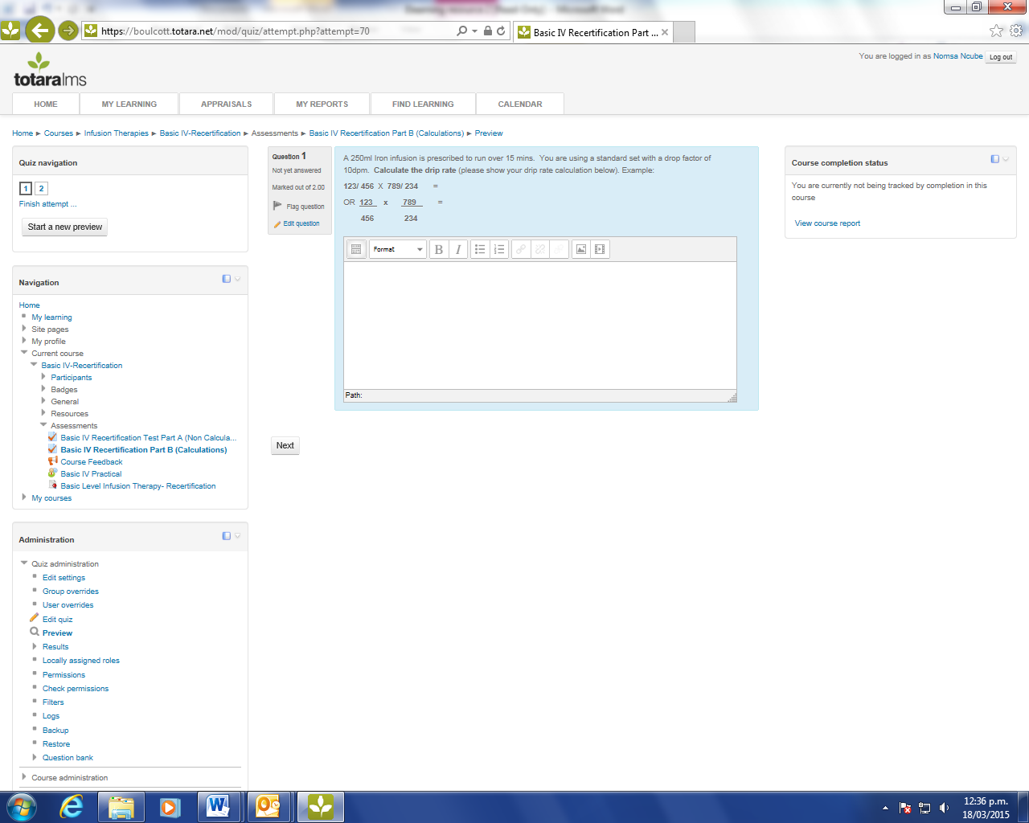

How do I use computer symbols for the answers?
Equals sign
=
Multiplication sign
Division
Sign

You can also use the symbols in the white space provided to underline as you write e.g.
123 x 789 =
456 234
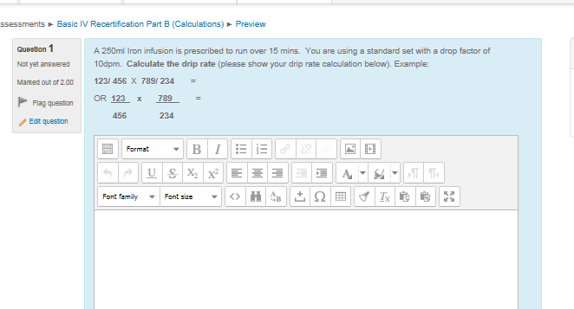
Division signs

How do I use the resources (manuals etc.) during the test?

There are two ways to view the resources while undertaking the test. Either view two windows on the one screen at the same time, or open into separate tabs (windows).

I want to open a resource on the same screen as the test
Practice this before you start your test
Hover your mouse over the resource you would like and click to open.

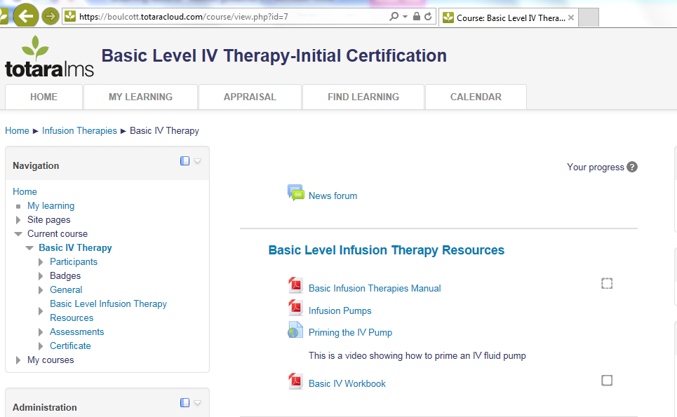

A new window with your selected resource will open as on the next page.

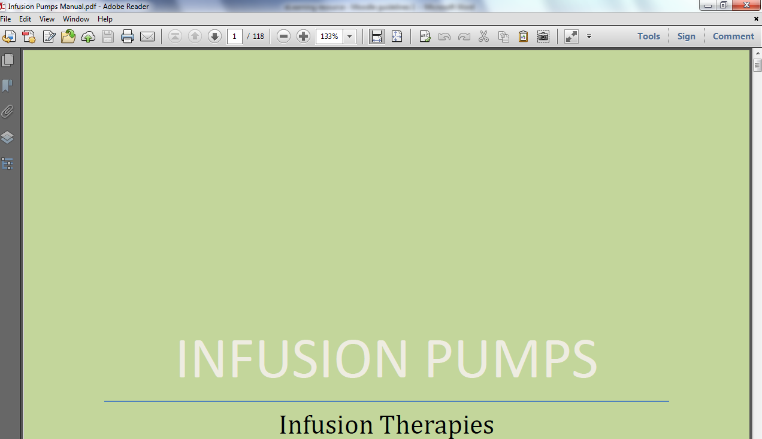

When you have opened the manual as above go back to the Moodle window where the resources and assessments are. Now you can click the test and click attempt when you are ready to and a window like this will open. On your upper left hand you will see the question number you are working on and the time left. You can move to the next question if you can’t find the answer and review later.

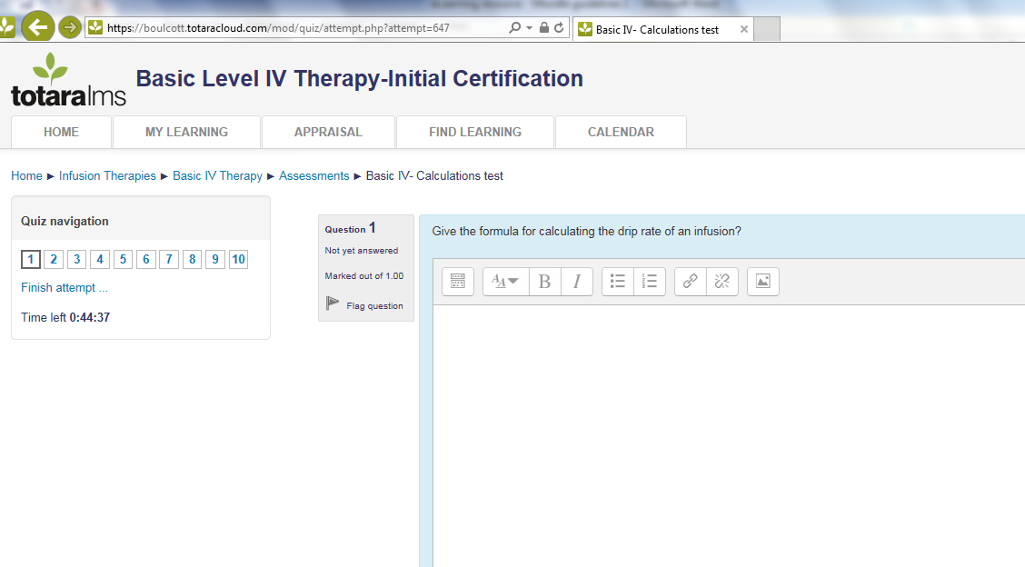
This is the view of questions and the time left

Minimize your windows by clicking this icon at your very top right hand corner

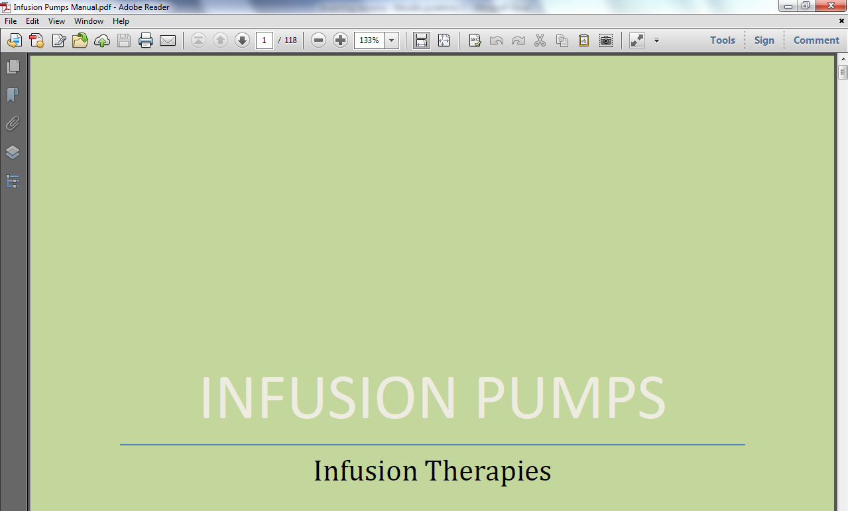

The window will be small and you click and hold the mouse on the blue area to move the window to the right hand side.

Click and hold down the left hand side of the mouse to drag your window across

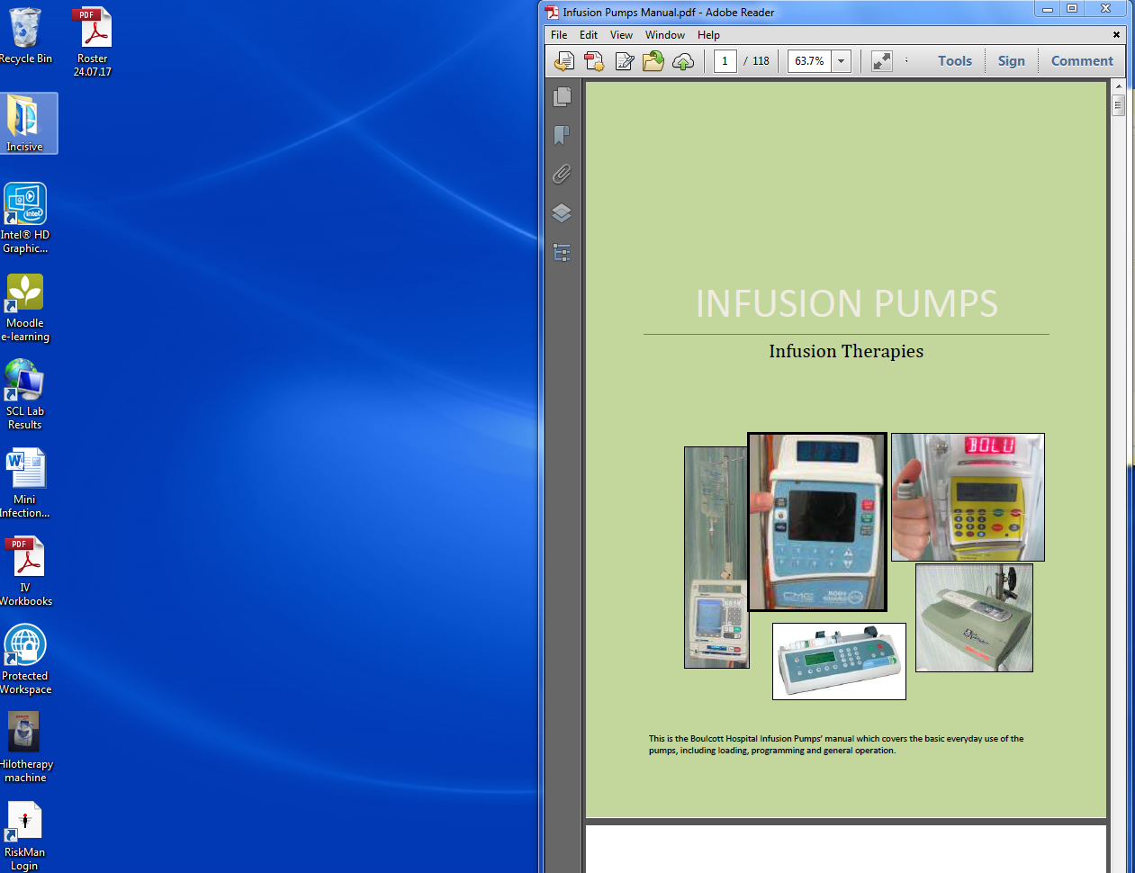

Minimize the test window as well like above. Blue areas at the top and side can be dragged slowly to sit like below. You will have your test and resource side by side.

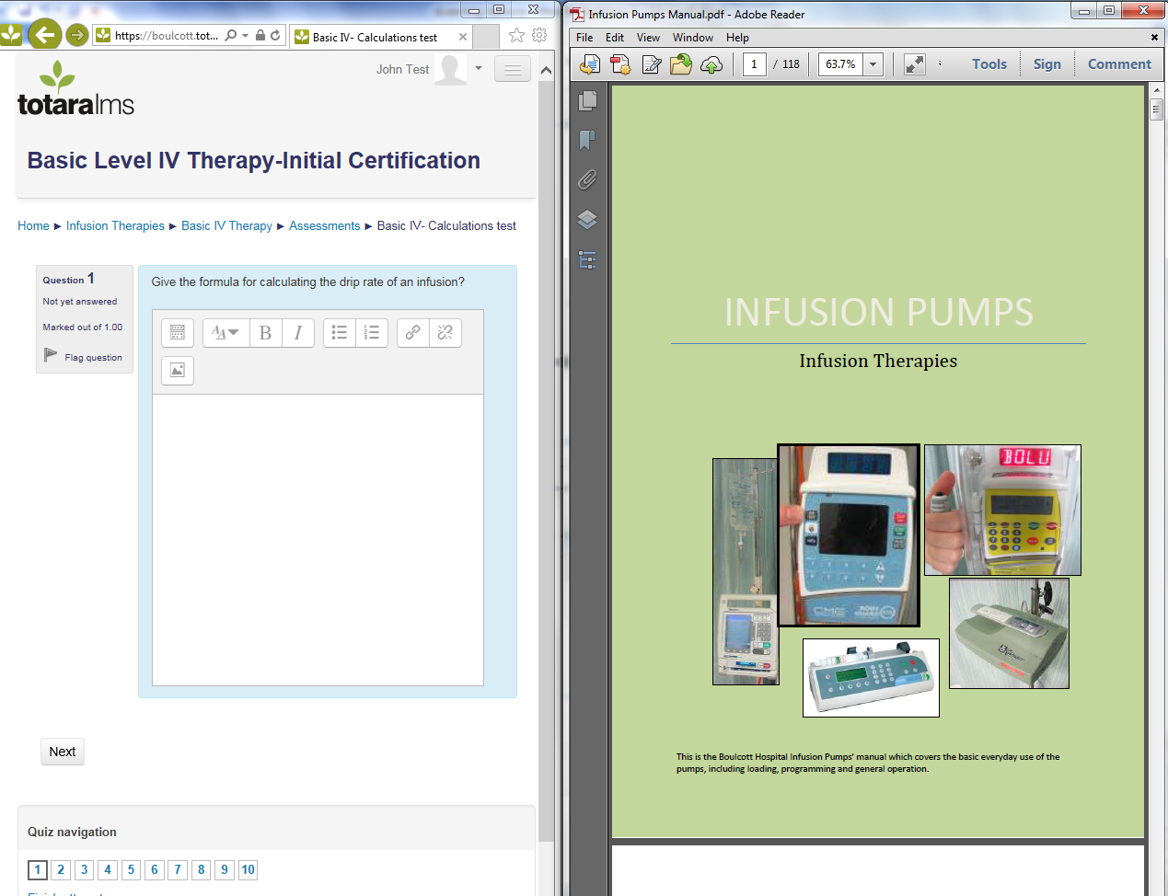

I want to have separate Tabs for the resources while taking the test

You can choose not to view two windows in one screen and switch between Tabs instead.

Just click the window you want to view and switch to the next as you wish.

Tabs can be seen at the top or at the bottom of your window.

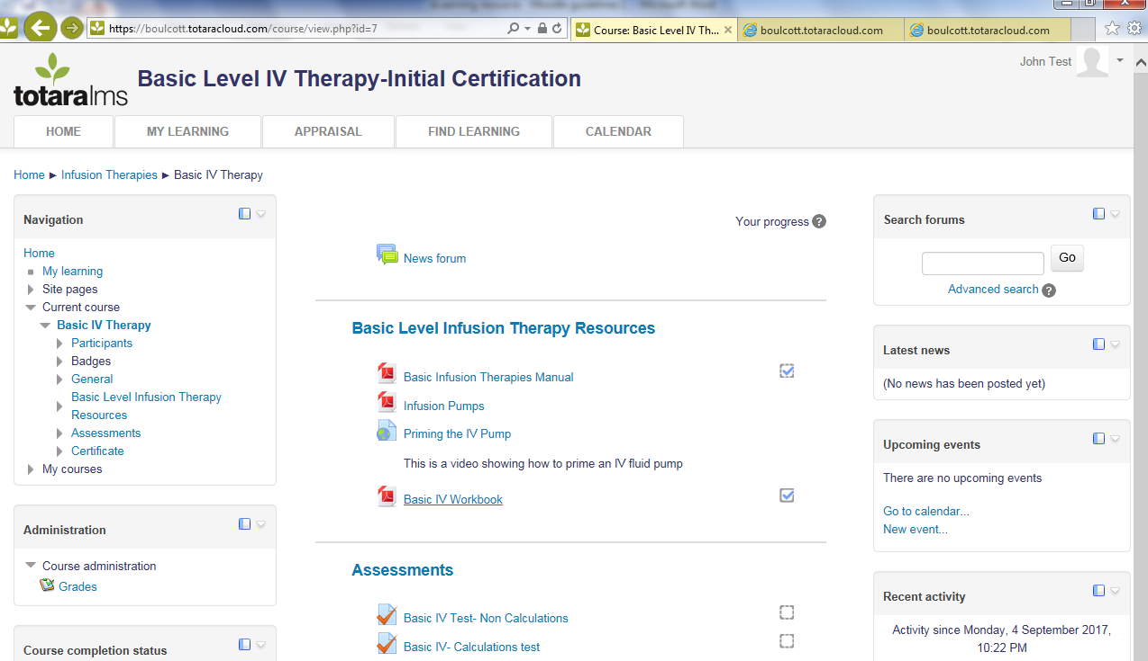
These are your tabs. Just switch to one of them one click
These can be at the bottom of your screen depending on the computer you using.

How do I change my profile settings and view my learning progress?

You can change your profile settings if you wish.

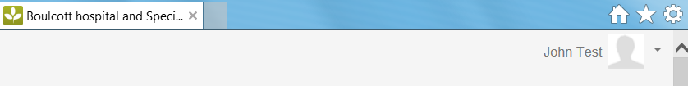
Log in and click the arrow next to your name and profile picture. From the new window that will open, you can choose any activity, view and change the look of your profile as you wish.

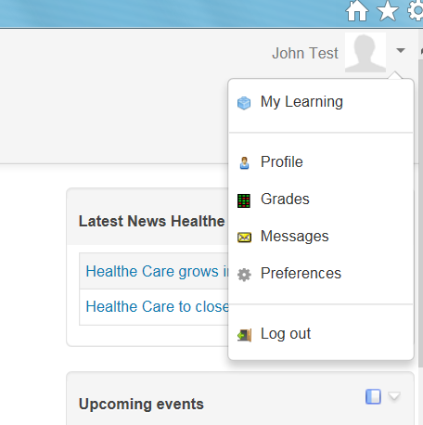
Choose any activity, view and change the look of your profile as you wish.
You are not able to alter results and reports.
And check your progress any time.

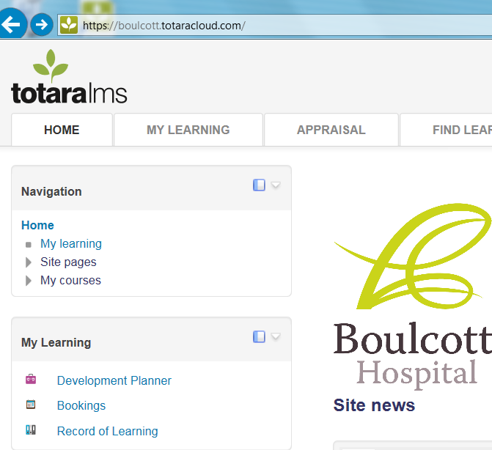
Click “My learning” for an overview of your courses

Or
Click “Record of Learning” to check the progress (completion level) of your courses

We want to hear from you!

When you have finished your theory test, please complete the online feedback in the ‘certificate and evaluation of learning’ section as shown.

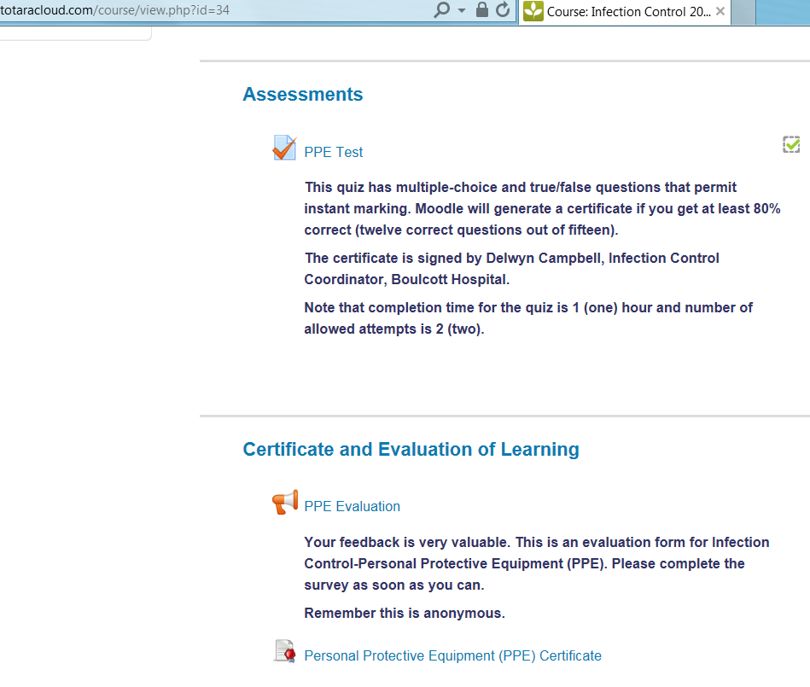
Feedback Survey

How to upload my study days and conferences reports on Moodle?
(So my manager can see them!)
First, you need to have the report saved in your computer or on a portable (mobile) device such as USB.
Log in and from the home page click on ‘Record of Learning” button.

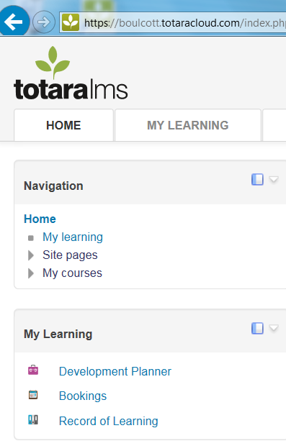
You will be taken to ’Record of Learning: All Courses’ page. Click on ‘Other Evidence’ button

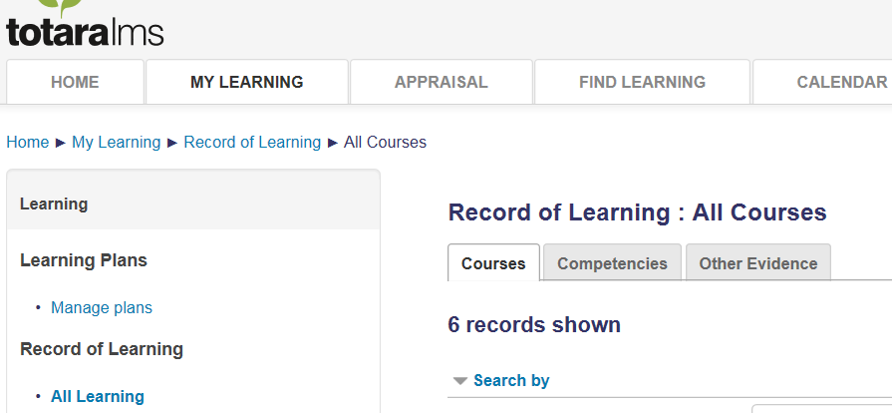
Then click ‘Add Evidence’. Here you can give a title to your document (in my example it is ‘Plastic Surgery Conference Feedback’). Also you can add a short description of the document.
Scroll down to the file attachment section.

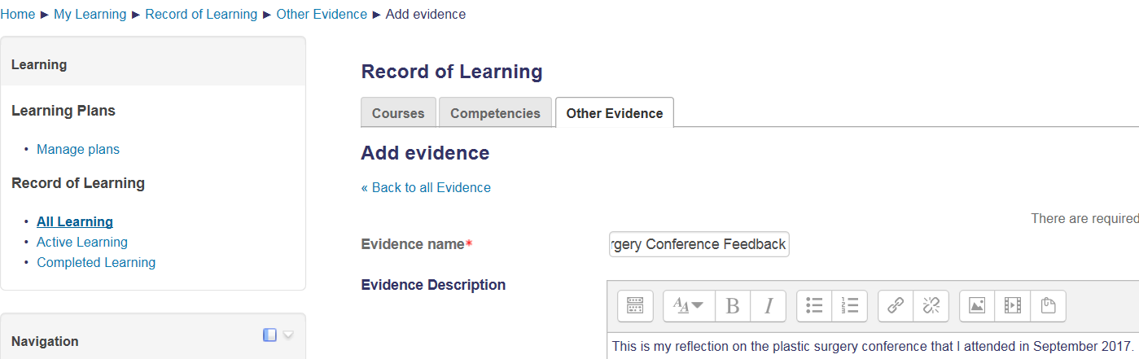
Document Title
Document Description

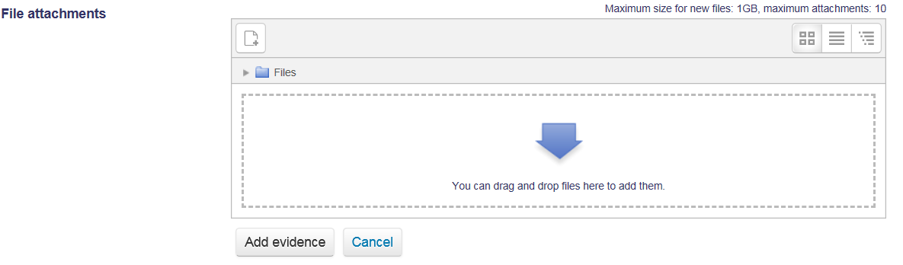
Click the add file button
A window like this will open. Now you can browse and choose the document that you want to add.
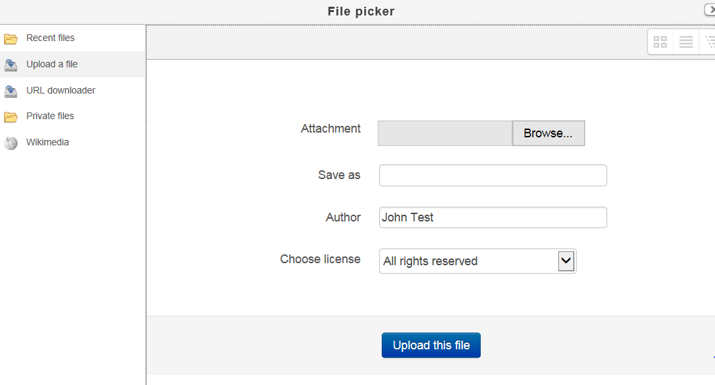
Click Browse

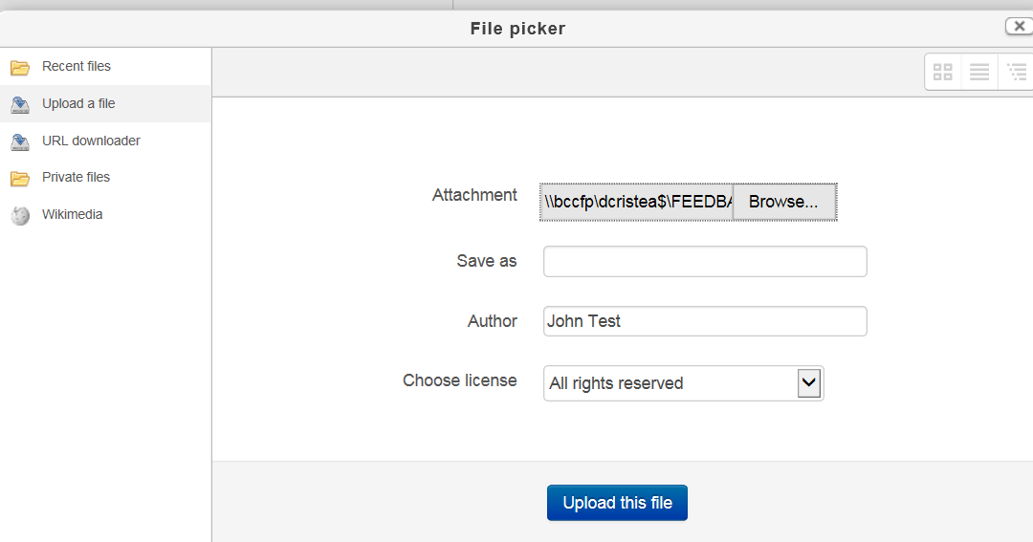
Now upload the file.
This will be your next page. The last step is to click on Add evidence and you will have the document inserted in Moodle. Your manager will be able to see, open and read it.
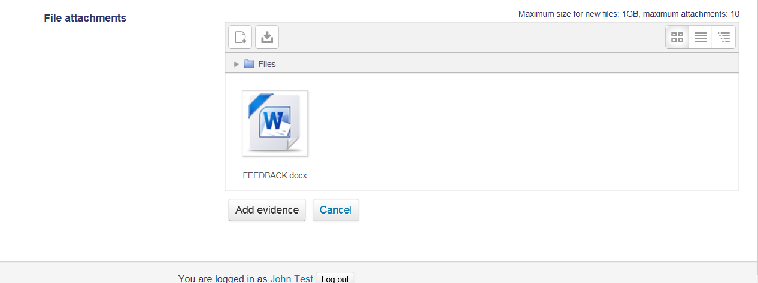
Click Add evidence

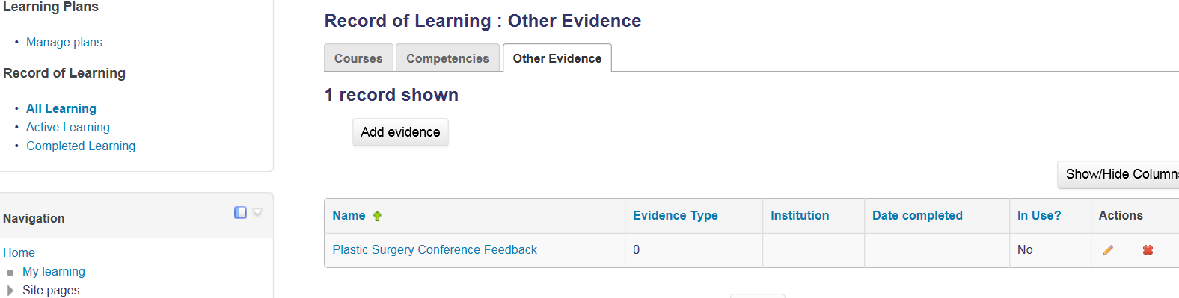

If you need online help with any course please contact Dalia Cristea on dcristea@boulcotthospital.co.nz or daliacristea@yahoo.co.nz OR extension 740 in the Ward

Happy learning!!!

